Christopher Fu
Biology 313
Discussion for the week of 11-13, 2017
15 points

1. Shown here is the receptive field of a simple cell in the visual cortex. This cell has an “off center” type of response, and light is falling on the center of its receptive field, as indicated by the shading
a. What layer of V1 would you most likely find this cell?
simple cell - recives LGN inputs, found in layer 4.

Have receptive fields with on center or off center, surround responses are opposite to center. Receptive field is in shape of bar.
b. (3pts) Show how the receptive fields of 3 LGN neurons that are presynaptic to this cell create this cell’s specific preference for the orientation of its center.

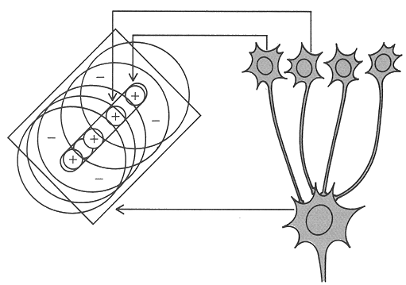

Similar to the above image, except the above image has 4-5 receptive fields.

c. for a stimulus that is a bar of light falling on the center of this cell’s receptive field:
show what its response would be

(light on)

d. Now show the response of an LGN cell that is presynaptic to this cell for light filling the center of LGN neuron’s receptive field
OFF CENTER:

(light on)
e. If a complex cell is receiving inputs from several simple cells like this, what would be the best stimulus for this complex cell?
When the stimulus is moving within the receptive field at the optimal orientation

f. What would that cell’s response be when it receives that stimulation?

(light on)

g. and where would this cell be located in the brain?
Layers 2-3 of primary visual cortex

2. There are a number of potential causes of hearing loss. For each of the problems described below, state:
a) what deficits in auditory discrimination would you expect to find?
b) why?
a. hair cells are damaged in a region midway along the length of the basilar membrane

Some frequencies may not be detected as well as those higher or lower than it due to basiliar/mechanical tuning.
b. the antibiotic ethacrynic acid poisons the cells that extrude K+ into the scala media
K+ is needed to depol hair cells, no AP from hair cells so lessened/ no hearing
c. pinna is removed
Difficulty localizing sound, and hard time determining human speech as it is not amplified. Ripples for localizing sound in vertical plane, point forward for front-back.

#2 WILL BE DONE IN CLASS. PLEASE READ, BUT YOU DO NOT NEED TO TURN ANYTHING IN FOR IT
2. Your TA will play a number of auditory demonstrations that will illustrate some examples of how we process sound. You will find the narrator is in need of an injection of a substantial amount of depolarizing current, but the demonstrations are interesting.

TRACK 8
a) This will illustrate what a dB sounds like. You will hear white noise (a large mix of frequencies) that decreases in intensity by different amounts (number of dB)

TRACK 17
b) We have different intensity thresholds for detecting different frequencies of sound. We are particularly insensitive to low frequencies, and are especially good at hearing around 4kHz, due to the resonance in our ear canal. In this demonstration, different frequencies will decline in intensity by 5dB over 10 steps. Count how many steps you can hear.

TRACK 22
c) This demonstration works because of the way that the basilar membrane responds maximally to different frequencies of sound at different positions along its length. When two tones that have somewhat similar frequencies are presented simultaneously, one tone can interfere with your detection of the other. This is called masking. The tone with the lower frequency is better at masking than the tone with the higher frequency, as is illustrated here.

TRACK 23
d) Masking can also occur when the test tone and its masking sound do not occur simultaneously. Forward masking is when the masking sound occurs shortly before the test tone, and is probably due to a refractory period in the sensory neurons. Backward masking is when you can’t detect a test tone that actually occurs up to 10msec before the masking sound! (Is this time travel?). This is believed to be due to some aspects of processing in the brain, where a higher intensity masking sound interferes with the weaker test tone. Check it out in this demonstration!

TRACK 27
e) The pitch of a tone is often said to be a function of its frequency. This is generally true, but other factors can also be involved. One of these is intensity. A number of studies have claimed that people hear the same frequency tone as having a different pitch, depending on its intensity. Some said the pitch increased, some said it decreased. See what you think.

TRACK 29
f) How many cycles of a sinusoidal sound do you need to hear, to hear it as a tone instead of a click? Some studies have said only 2 cycles are enough. See what you find. These tones are presented with 1, 2, 4, 8, 16, 32, 64 and 128 cycles.

TRACK 48
g) We can listen to sounds in different modes. When we listen analytically, we hear different frequency components separately. When we listen synthetically, or holistically, we focus on the whole sound, and pay little attention to its frequency components. Here you will hear a 2 tone complex of 800 and 1000Hz, followed by one of 750 and 1000. If you listen analytically, you will hear the pitch of the second combination go down, if you listen synthetically, you will hear it go up. How do you hear it?

TRACK 70
h) Echoes come from sound being reflected back to our ears after bouncing off a wall, ceiling or floor of an enclosed space (i.e. a room). Our auditory system often ignores echoes, even though they are usually present. Can you hear an echo in the classroom when your TA snaps his fingers? In this series, the echoes are made obvious when the sounds are played backwards. You will hear sounds in three types of room: a room that has no echoes (anechoic), a typical conference room, and a highly reverberant room. You will also notice the quality of the man’s voice change in the different rooms, even when the demos are played foreward. This is due to the effects of the echoes too.

